

**READING TEST**

In the Reading test, you will read a variety of texts and answer several different types of reading comprehension questions. The entire Reading test will last 75 minutes. There are three parts, and directions are given for each part. You are encouraged to answer as many questions as possible within the time allowed.

You must mark your answers on the separate answer sheet. Do not write your answers in your test book.

PART 5

Directions: A word or phrase is missing in each of the sentences below. Four answer choices are given below each sentence. Select the best answer to complete the sentence. Then mark the letter (A), (B), (C), or (D) on your answer sheet.

|  |  |  |
| --- | --- | --- |
| 101. Vantage Automotive Design has recently  ----- with the Pallax Company. | 105. | Ms. Patel is coming to Delhi today to visit possible for her company's new |
| 1. merge 2. merger |  | warehouse.  (A) locating |
| 1. merged 2. merging |  | 1. locations 2. located 3. locate |
| 102. Rain is predicted this weekend, the  office picnic will have to be postponed. | 106. | Clydeway, Inc., has grown dramatically |

1. so
2. for
3. but
4. nor
5. Use an alternative shipping firm if Greer Freight is unable to expedite delivery of

---- order.

* 1. you
  2. your
  3. yours
  4. yourselves

1. The cafeteria is featuring dishes -------

different regions of the world this week.

* 1. over
  2. through
  3. into
  4. from

- -- its beginnings as a small corner grocery store.

1. since
2. such
3. except
4. however
5. When booking a flight, it is wise to the

guidelines for luggage size on the airline's Web site.

* 1. check
  2. close
  3. approve
  4. list

1. The melody is so that the composer

has simplified parts of it for live performances.

* 1. direct
  2. complex
  3. favorable
  4. helpful



|  |  |  |
| --- | --- | --- |
| 109. The test group found the illustrations in the appliance users' guide to be highly - ----- | 115. | The city council will discuss certain policies, particularly those made the previous |
| (A) inform |  | administration. |
| 1. information 2. informatively 3. informative |  | 1. any 2. by 3. to |
| 110. The directions for Masuda's do-it-yourself |  | (D) and |
| projects are comprehensive enough for  ---- a novice builder. | 116. | Servers' tips are pooled at the end of each shift and divided evenly the entire |
| (A) right |  | waitstaff. |
| 1. soon 2. how 3. even |  | 1. onto 2. amorg 3. beside 4. about |
| 111. of the two candidates for the position |  |  |
| had the necessary qualifications. | 117. | Costpa Analytics Ltd. has made successful |
| (A) Neither |  | ---- in two emerging data companies. |
| 1. Nobody 2. None 3. Nothing |  | 1. investments 2. invested 3. invest |
|  |  | (D) investor |
| 112. The need for highly trained electricians in |  |  |
| the construction has grown rapidly in  recent years. | 118. | Vallentrade manages clients' accounts more than most other brokerage |
| (A) employment |  | firms. |
| 1. activity 2. knowledge 3. industry |  | 1. conserves 2. conservative 3. conservatively |
|  |  | (D) conserving |
| 113. Ms. Daly will prepare a marketing budget |  |  |
| and propose during the client  meeting. | 119. | The ideal operating temperature for the tablet computer is 10 and 30 degrees |
| (A) those |  | Celsius. |
| 1. its 2. it 3. her |  | 1. between 2. above 3. in |
|  |  | (D) off |
| 114. Mr. Silva asked sales staff to travel |  |  |
| expenditures to help cut costs. | 120. | Of the people who have publicly introduced |

* + 1. convince
    2. require
    3. decide
    4. limit

--- at the Carpentry Club meetings, about half are commercial contractors.

1. their
2. their own
3. they
4. themselves



1. On Thursday, the technician will be on Sratus Road two gas stoves.
   1. serviced
   2. service
   3. to service
   4. is servicing
2. The spreadsheet data on retail sales

during the fourth quarter is attached.

* 1. contains
  2. contained
  3. containing
  4. containable

1. See our weekly promotional flyer for complete of the discounted items.
   1. exchange
   2. support
   3. receipts
   4. descriptions
2. New salespeople are instructed to research the businesses of customers before

contacting them for the first time.

* 1. total
  2. potential
  3. equal
  4. factual

1. If you use online banking, bills can be paid

--- it is most convenient.

* 1. whenever
  2. simply
  3. accordingly
  4. quite

1. Our internship combines lectures with real- world projects to provide formal instruction

---- professional experience.

* 1. above all
  2. as well as
  3. nov.‘ that
  4. in order to

1. Employee ------- at Medmile Ventures include share options and scheduled raises.
   1. beneficial
   2. beneficially
   3. benef.ts
   4. benefited
2. City hope to get the necessary

permits to build a twenty-story office building on Minerva Street.

* 1. agendas
  2. developers
  3. avenues
  4. boundaries

1. Compliance Department officers regularly monitor changes in the framework.
   1. regulate
   2. regulates
   3. regulator
   4. regulatory
2. The X250 portable heater achieves the desirable without reaching especially

high temperatures.

* 1. practices
  2. factors
  3. outcomes
  4. dimensions

PART 6

**Directions:** Read the texts that follow. A word, phrase, or sentence is missing in parts of each text. Four answer choices for each question are given below the text. Select the best answer to complete the text. Then mark the letter (A), (B), (C), or (D) on your answer sheet.

**Questions 131-134** refer to the following information.

Thank you for shopping with Danforth Fashions online. Our quality-control team carefully inspects

all products -

13›

packaging to ensure customer satisfaction

-132:

If not, we make exchanges

or returns easy. Simply contact us at [service@danforthfashions.com](mailto:service@danforthfashions.com) if you need a different size,

color, or pattern—or if you are dissatisfied for any reason. Your exchange -133dright away. To return an item for a refund, use the prepaid return shipping label included with your order and

send it back to us in its original packaging unused and undamaged. We issue refunds to the

original method of payment, -134: the return shipping fee.

1. (A) in case
2. as much as
3. prior to
4. in keeping with



133. (A) will be processed

1. was processed
2. is processing
3. to be processing



132. (A) We hope you are entirely pleased with 134. (A) past your purchase. (B) above

* 1. We expect to be redesigning our Web (C) aboard site this summer. (D) minus
  2. We value all of our loyal customers.
  3. We noticed that your billing address has changed.



Questions 135-138 refer to the following notice.

Attention, Alden-Apner Industries Employees:

Please remember that the switch to our new e-mail software wili begin at 11:00 P.M. on Sunday,

May 2. All -13a. information in your account, including contacts and calendar events, will be moved to the new system by 4:00 A.M. on Monday, May 3. Though we are working diligently to

anticipate and provide solutions for all potential issues, some employees may experience

difficulty -13a attempting to log in to their accounts after the switcia. In addition, there is a remote possibility that some information may be lost -137: , be sure to back up any critical e-mail files as soon as possible. -: 3 : A training session will be scheduled next week to familiarize employees with key functions of the new software.

1. (A) existed
2. existence
3. to exist
4. existing
5. (A) when
6. plus
7. already
8. whose
9. (A) Previously
10. Otherwise
11. Even so
12. For this reason
13. (A) The new software will be ordered this week.
14. The current system will be reactivated in June.
15. If you need assistance with this, please contact the IT department.
16. In that case, you must complete the installation yourself.

Questions 139-142 refer to the following e-mail.



From: Hong Truong [<htruong@jansenwebbfoundation.ca>](mailto:htruong@jansenwebbfoundation.ca) Sent: Friday, 16 November

To: Staff, Friends, and Stakeholders Subject: JWF's new budget director

To the JWF team and our community partners:

-139:

I just want to let you know that Sofia Vargas -:4v as the Jansen-Webb Foundation's new

budget director. Ms. Vargas has a strong background in fiscal :4: within the nonprofit sector. Ms. Vargas brings with her a wealth of experience in organizational finance, including most recently at The Lawton Children's Centre in Winnipeg. Ms. Vargas started her employment with us this morning, so please stop in and introduce :42. to her.

Best,

Hong Truong

CEO, Jansen-Webb Foundation

1. (A) This is a request to be prompt.
2. Thanks for the generous contribution.
3. All are welcome here.
4. I hope that all are well.
5. (A) is hiring
6. will be hired
7. has been hired
8. is being hired
9. (A) referral
10. administrator
11. running
12. management
13. (A) yourself
14. him
15. them
16. ourselves



Questions 143-146 refer to the following flyer.

Jamaica National Tourist Organization Offers Free Cultural Passes

The Jamaica National Tourist Organization (JAMTO) announces an exciting new program that provides free entry to a variety of cultural attractions. The program is sponsored by the JAMTO

-143:

the hotels and businesses listed on the back of this flyer. Together we -1

44

dyou to take

advantage of some of the finest cultural and educational experiences that Jamaica has to offer.

-14:

attractions include Caribbean National Gardens, Montego Bay Potters Gallery,

the

Jamaican Music Experience, and many others.

To obtain your pass, visit our Web site at [www.jamto.org/freepass](http://www.jamto.org/freepass) or stop by any JAMTO office. One pass is valid for up to five people ›46:

1. (A) despite
   1. instead of
   2. except for
   3. along with
2. (A) invite
3. invited
4. may invite
5. were inviting
6. (A) Early
7. Past
8. Affordable
9. Participating
10. (A) Thank you for your order.
11. It can be used for three days.
12. The bus runs only on weekdays.
13. All major credit cards are accepted.

PART 7

Directions: In this part you will read a selection of texts, such as magazine and newspaper articles, e-mails, and instant messages. Each text or set of texts is followed by several questions. Select the best answer for each question and mark the letter (A), (B), (C), cr (D) on your answer sheet.

Questions 147-148 refer to the following text-message chain.

Jun Kambayashi [10:12 A.M.] Rachel, it looks as if Mr. Tanaka's flight will be arriving 30 minutes earlier this afternoon. I“m on my way to pick him up.

Rachel Newman [10:13 A.M.] The staff are excited that he finally is going to be worl‹ing with us here. Do you think the two of you have time to stop here in the office before the end of the workday?

Jun Kambayashi [10:14 A. -l Probably. And I agree; Mr. Tanaka has done great work at our Chiba branch.

Rachel Newman [10:15 A.M.] So I've always heard. It would be nice for him to get a quick tour of the lab and meet some members of the team before our welcome dinner.

Jun Kambayashi [10:16 A.M.] Sounds good. Since flight schedules can be unpredictable, I'll keep you posted as I arrive at the airport.

Rachel Newman [10:17 A.M.] Perfect. See

you later.

1. Who most likely is Mr. Tanaka?
   1. A new laboratory owner
   2. An important client
   3. A transferred staff member
   4. An airline pilot
2. At 10:16 A.M., what does Mr. Kambayashi mean when he writes, “Sounds good”?
   1. He is pleased with the dinner arrangements.
   2. He likes the idea of stopping by the office before dinner.
   3. He appreciates Mr. Tanaka's professional reputation.
   4. He is glad that team members have completed their work.



Questions 149-150 refer to the following e-mail.



Dear Ms. Hardesty,

This is to share an important change concerning the 18 August, 4 P.M. Marketing Skills Workshop. Because many more attendees have signed up, we have changed the location of our event to

The Rill Inn; PERTH

*Please acknowledge* you *are uware o( the update.* I would appreciate it if you could treat this request as urgent and reply as soon as convenient. Should you have any questions about participation, you can e-mail me.

Thank you, Andrew Jenkins

Workshop Organizer

jenkins Hourmarketfocus.au hardesty Hgallusmail.au

11 August Workshop Notice

From: To: Date: Subject:

~~—~~

~~—~~

~~-~~  E-Mail Message  ~~—~~

1. What is the purpose of the e-mail?
   1. To cancel an event
   2. To announce a new venue
   3. To recruit new workshop presenters
   4. To request volunteers for a workshop
2. What is Ms. Hardesty asked to do?
   1. Share the notice with other attendees
   2. Choose a convenient time to meet
   3. Confirm receipt of the message
   4. Update her contact information

Questions 151-152 refer to the following advertisement.



Virens

Come to Virens for the best televisions, phones, tablets, and more!

Grand Opening Celebration

featuring comedian and DJ Declan Gibb from radio station KYX 93.8

Saturday, October 2, 10:00 A.M.—8:00 rsi. 234 Morris Avenue, next to Mike's Pizza

Complimentary snacks from Sarah's Bakery—home of Sarah’s delicious pastries!

Bring this ad for $5 off a purchase of $10 or more.

Valid throughout October.

1. What type of business is Virens?
   1. A pastry shop
   2. A radio station
   3. An electronics store
   4. A pizza restaurant
2. According to the advertisement, what will happen on October 2 ?
   1. Declan Gibb will perform at an event.
   2. Two businesses will move to new locations.
   3. A new product will be launched.
   4. A coupon will expire.



Questions 153-154 refer to the following Web page.



|  |  |  |
| --- | --- | --- |
| [http://www.officenature.com](http://www.officenature.com/) | | |
|  | Want to boost the health and morale of your employees? Office Nature  dell *ers a box filled with delicious food right to your break room.  We focus on the following.   * providing natural treats such as nuts, granola, and dried fruit * working with local farmers to provide the freshest options * reducing impact on the environment * offering foods at reasonable prices   Just choose your selections and delivery day, and a fresh box of healthy food items will be brought automatically each week. First-time customers receive 10% off their order with code YUM. |  |
|  |
|  |
|  |  |

1. For whom is the Web page most likely intended?
   1. Farmers
   2. Business owners
   3. Company employees
   4. Office Nature staff
2. What is indicated about Office Nature?
   1. It delivers healthy snacks.
   2. It offers weekly discounts.
   3. It makes its own baked goods.
   4. It grows its own fruit.

Questions 155-157 refer to the following magazine article.

Spotlight on Geiger Travel

Wanting to combine his passion for exploring places and cultures with his career as a corporate travel consultant, Marcus Geiger founded Geiger Travel Management (GTM). Now, ten years later, the company has offices in the United States, Canada, and several South American nations. It crafts itineraries and facilitates travel and accommodation arrangements for business professionals.

GTM also oñers its clients secure, high- speed computers, conference call systems, and file management software through an agreement with Balefire Electronics, located in Mumbai. “We owe a lot of our success to Balefire,” says Mr. Geiger, “because their

1. What is indicated about Mr. Geiger?
   1. He regularly goes to Mumbai for business.
   2. He has overseen the expansion of a business.
   3. He decided to become a travel writer ten years ago.
   4. He used to work for a hospitality company.
2. What service does GTM offer?
   1. Booking hotels for executives
   2. Leading cross-cultural training workshops
   3. Providing translation services at conferences
   4. Furnishing overseas branch offices

services enable our clients to work efficiently wherever they are.”

Mr. Geiger is optimistic that further growth is on the horizon for GTM. Two additional businesses, Apura Airways, based in Paramaribo, Suriname, and the restaurant chain Triggerfish, headquartered in Bridgetown, Barbados, have agreed to enter into strateg•ic partnerships with GTM in August. And looking to launch operations in Europe, the company is currently in discussions with Krokushaus AG, a hospitality company with locations throughout Germany.

For more information about Geiger Travel Management, visit [www.gtm.com.](http://www.gtm.com/)

1. GTM does NOT have an agreement in place with which company?
   1. Balefire Electronics
   2. Apura Airways
   3. Triggerfish
   4. Krokushaus AG



**Questions 158-160** refer to the following press release.



**FOR IMMEDIATE RELEASE**

**Contact: Sherylin Stevens,** [**sstevens@tearsoncorp.ca**](mailto:sstevens@tearsoncorp.ca)

CALGARY (2 November)—Yves Vernier, the Chief Information Officer of the Tearson Corporation, announced on Monday that 200 robots will soon appear in Teai’son’s grocery stores. The robots, which are all named Bailey, will be used to locate areas where boxes or bottles have fallen and broken, spilling cereal, juice, or other substances onto the floor. The robots will report the spills so that the locations can be cleaned by store employees before they become safety hazards.

The robots were tested in Calgary, where Tearson's head office is located. During the eighteen-month pilot programme, store managers consistently gave the robots high marks. Although the robots have been used in the company's warehouses for several years, this will be their first time working in stores and interacting with customers. All Tearson stores should have the robots by the beginning of Decembcr.

For more information, visit Tearson Corporation at [www.tearsoncorporation.ca.](http://www.tearsoncorporation.ca/)

1. What is the topic of the press release?
   1. The promotion of a company executive
   2. The use of technology in stores
   3. The launch of new product lines
   4. The relocation of a company's head office
2. What can Bailey do?
   1. Clean a mess on the floor
   2. Create labels for products
   3. Find areas that have spills
   4. Locate items for customers
3. What is suggested in the press release?
   1. A pilot program in Calgary was a success.
   2. Tearson stores will be renovated in December.
   3. A warehouse earned high marks for safety features.
   4. Managers will be hired in several stores.

Questions 161-163 refer to the following e-mail.

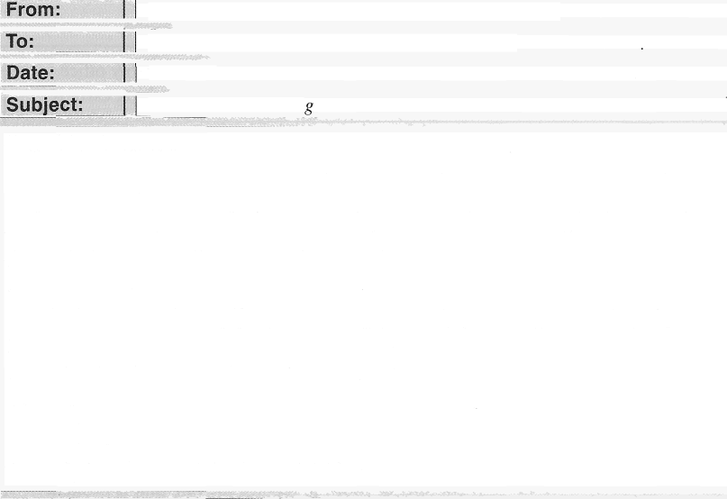



|  |  |  |
| --- | --- | --- |
| Helen Dietrich <hdietrich H morphospublishing.ca> | |  |
|  | Alia Cervantes <a1ia.cervantes Hgotomail.ca> |  |
|  |  |
| 3 March |
|  |  |
| *Practical Gardenin* |  |
|  |  |  |
|  | Dear Ms. Cervantes:  I am sorry to report that next month's issue of *Practice/ Garcleniii,¿* will be our last. After 62 years of monthly issues, we at Morphos Publishing have decided that *Practiccil Gardening* will be among the periodicals that we must discontinue. We plan to redirect the resources gained through cost-cutting toward growing our book publishing and instructional video production businesses.  We are grateful for your support as a longtime subscriber to *Prac'tical Gat denim g.* For the remainder of your subscription term, we hope you will allow us to instead send you *Flora Discove ,* our popular publication about wild plants. However, if you would rather have the balance of your subscription account refunded to you, please contact us at  (822) 555-0127.  Sincerely,  Helen Dietrich  Subscription Manager, Morphos Publishing |  |

1. What is the purpose of the e-mail?
   1. To apologize for a delay
   2. To promote a new product
   3. To announce a cancellation
   4. To address a billing error
2. What most likely is *Practical Gardening* ?
   1. A film
   2. A book
   3. A Web site
   4. A magazine
3. The word “balance” in paragraph 2, line 4, is closest in meaning to
   1. amount remaining
   2. stability
   3. increase in cost
   4. production



Questions 164-167 refer to the following online chat discussion.

|  |  |  |  |
| --- | --- | --- | --- |
|  | | | |
| Lindsay Pokora (2:15 P.M.) Hello, Mr. Kopalinski. I need to place the monthly office supplies order. In addition to the regular items, can you let me know if anything extra is needed?  **Craig Kopalinski** (2:17 P.M.) Let me check with the other managers. Kaitlyn and Jeffrey, do you have any requests for office supplies in your departments?  Kaitlyn Daley (2:18 P.M.) Yes, we need more whiteboard markers.  **Craig Kopalinski** (2:19 P.M.) And how about accounting! Jeffrey Carden (2:20 P.M.) Nothing here.  **Lindsay Pokora** (2:22 P.M.) Markers? I just checked our inventory and we still have a box in the supply room. Do you need a special kind?  Kaitlyn Daley (2:23 P.M.) No, just regular black markers. Three boxes should be enough.  I tried some markers from the box we have, but they seem to have dried up. A group of new employees will be starting next week, and we'll need markers for the orientation and training sessions.  **Craig Kopalinski** (2.24 P.M.) OK. Lindsay, in addition to those markers, could you please order a new chair for the second-floor conference room to replace the one that is broken?  You'll need to look up the model number. Thanks. | | |  |
|  |
|  |
|  |  |  |  |

1. At 2:20 P.M., what does Mr. Carden most likely mean when he writes, “Nothing here”?
   1. He has not heard from Ms. Pokora.
   2. He does not need to place an order.
   3. He does not have extra markers.
   4. He has not checked the supply room.
2. What problem does Ms. Daley report?
   1. Some presentations are too long.
   2. Expenses in the office have increased.
   3. Some office supplies cannot be used.
   4. The conference room is not big enough.
3. In what department does Ms. Daley most likely work?
   1. Accounting
   2. Human Resources
   3. Purchasing
   4. Shipping
4. What will Ms. Pokora most likely do next?
   1. Locate some information
   2. Review a training document
   3. Conduct an orientation session
   4. Contact department managers

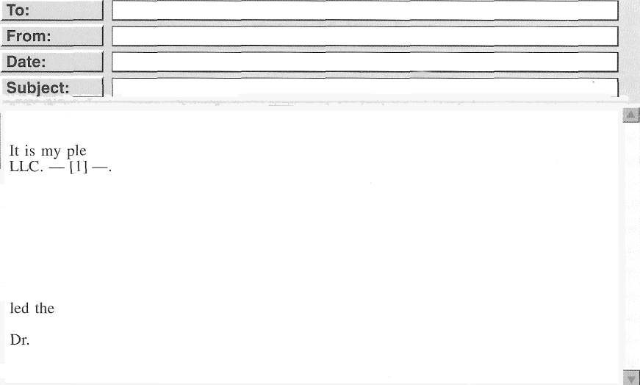Questions 168-171 refer to the following e-mail.



|  |  |  |  |
| --- | --- | --- | --- |
| All staff  Jan Merchant  October IS  Reginald Carmen | | |  |
|  |  |  |
|  | Dear Colleagues,  asure to welcome Reginald Carmen to Edmonton Engineering Consultants,  With his expertise in engineering and education, Dr. Carmen will be a valuable addition to our distinguished staff. — [2] —. Upon graduating from university, he spent six years designing telecommunications systems for AstroPart, Inc. He comes to us directly from the Glasse School of Engineering, where he spent the past nineteen years. While there, he served as a full-time professor for ten years, teaching advanced mathematics and various special courses in engineering. He was then appointed president of the school and served in that position for the remaining nine years of his tenure. — [3] —. During that time, he  team that redesigned the school’s electrical enqq•ineering curriculum—. [4]  Carmen's hrst day will be next Tuesday.  Jan Merchant, Director of Personnel |  | |
|  |  | | |

1. Why did Ms. Merchant send the e-mail?
   1. To announce that she is retiring
   2. To provide details about a new employee
   3. To welcome a distinguished guest presenter
   4. To publicize expansion into a new line of business
2. What is indicated about Dr. Carmen?
   1. He has experience designing communications systems.
   2. He worked as a consultant for Edmonton Engineering Consultants in the past.
   3. He mentored Ms. Merchant at another company.
   4. He graduated from the Glasse School of Engineering.
3. How long did Dr. Carmen teach at the Glasse School of Engineering?
   1. 6 years
   2. 9 years
   3. 10 years
   4. 19 years
4. In which of the positions marked [1], [2], [3], and [4] does the following sentence best belong?

“He is thus the perfect choice for redesigning our client training modules."

(A) [1]

(B) [2]

(C) [3]

(D) [4]



Questions 172-175 refer to the following review.

# Patrons See Big-City Art At Local Museum

No need to venture into the big city to see an impressive art collection. — [l] —.

Locals know Janford as a quiet town situated next to a forest that is popular with hikers.

— [2] —. It is likewise home to Janford University and an unexpectedly outstanding museum. Considered one of the finest university art museums in the nation, the Janford University Art Museum (JUN.M) houses over 94,000 pieces, with works dating front ancient times to the present. Due to the size of its collection, the museum regularly rotates the works on display. — [3] —. It also hosts temporary exhibitions featuring loans from other institutions.

Experts consider JUAM noteworthy as a home to a comprehensive collection of twentieth- century art. — [4] —. In particular, it holds the largest public collection of works by sculptor Robert Dabulis, with more than 50 of his pieces and an assortment of his sketches.

The museum offers free admission and is open daily from 10 A.M. tO 5 P.M. On Friday evenings, the museum has extended hours until 10 P.M.

1. What does the review indicate about the 175. In which of the positions marked [1], [2], [3], town of Janford? and [4] does the following sentence best
   1. It is in a peaceful setting. belong?
   2. It is more than 100 years old.
   3. It has a thriving community of artists.
   4. It has a well-known school of forestry.
2. What is mentioned about the museum?
   1. Its main focus is on ancient art.
   2. It has received several national awards.
   3. Its location makes it difficult for tourists to find.
   4. It displays some items from its collection for only a limited time.
3. What is most likely true about Mr. Dabulis?
   1. He began his work as a painter.
   2. He created sculptures specifically for JUAM.
   3. He created art during the twentieth century.
   4. He studied art at Janford University.

“Art enthusiasts can find it right here in Janford.”

(A) [1]

(B) [2]

(C) [3]

(D) [4]



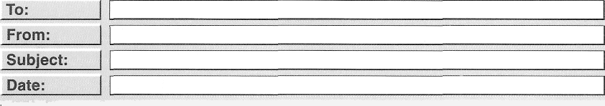Questions 176-180 refer to the following order form and e-mail.

|  |  |  |
| --- | --- | --- |
| Ready Born  Order # #13S6S  Date: I une 3  Delivery: 24-hour Express Shipping Shipping Address: Helen hang  45 Skyrise Road  Newten, NY 12039  Payment Method: Credit Card—day Shim | | |
| Item Number | Description | Price |
| 7563 | Countertop Electric Grill | $49 |
| 7564 | Egg Beater | $14 |
| 7565 | Tea Kettle | 527 |
| 7566 | Toaster | 556 |
| 7567 | Cheese Grater | $16 |
| 24-hour Express Shipping $20  TOTAL $182 | | |

|  |  |  |
| --- | --- | --- |
| customerservice Mreadybarn.com  jayshini H si1yex.com  Order #13565  June 6 | | |
|  | Hello,  1 recently placed an order (#13565) with Ready Barn. The items I purchased are housewarming gifts for my niece, Helen Kang, who recently ptu‘chased a new home. Therefore, her address was provided as the delivery destination. I paid higher shipping fees for 24-hour delivery, as I wanted the items to arrive well ahead of the housewarming party being held tomorrow evening. Several days have passed, and my niece has yet to receive these items. I would appreciate it if you could find out what has happened and let me  know when my niece can expect delivery. Also, I would like to ask you to return the money I paid lor expedited shipping.  Additionally, I do not recognize item number 7564 that I was charged $14 for on my receipt. Please let me know how to send it back.  I am a longtime customer of Ready Barn, and I am usually very satisfied with your products and services. Please reply as soon as possible.  Sincerely,  Jay Shim |  |
|  |  |



|  |  |  |
| --- | --- | --- |
| 176. What most likely does Ready Barn | 179. | What item did Mr. Shim not intend to buy? |
| specialize in?  (A) Kitchen equipment |  | 1. The cheese grater 2. The grill |
| 1. Party invitations 2. Shipping supplies 3. Large appliances |  | 1. The toaster 2. The egg beater |
| 177. What is indicated about 45 Skyrise Road? | 180. | According to the e-mail, what is true about Mr. Shim? |
| 1. It is Ready Barn's address. 2. It is Mr. Shim's billing address. 3. It is Ms. Kang's new address. 4. It is Mr. Shim's former address. |  | 1. He is satisfied with the items he purchased. 2. He has shopped with Ready Barn before. |
|  |  | (C) He rr’.ceived his order on schedule. |
| 178. What does Mr. Shim request in his e-mail? |  | (D) He prefers to shop through a catalog. |
| (A) A discount |  | |
| (B) A refund |
| (C) A receipt |
| (D) A gift list |



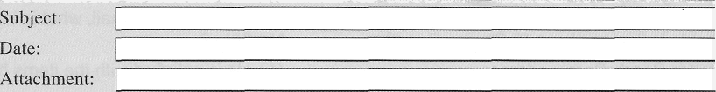Questions 181-185 refer to the following e-mail and boarding pass.

|  |  |  |  |  |
| --- | --- | --- | --- | --- |
|  | | IE-mail |  |  |
| To: Yong Sun Che <ysche buztech com> | | | |  |
| From: Ginny Redman <gredman Asilvervaleair.cor.a> | | | |  |
| RE: Seat problem February 12  J Voucher | | | |  |
|  | Dear Mr. Che:  Thank you for contacting us regarding your recent tlight. We apologize for the discomfort you experienced during your flight because of the nonfunctioning air-conditioning vent above your seat.  We value you as a customer and want to make sure your experience with Silvervale Air is positive, so we have attached Voucher 789798 in the amount of $200. This may be applied to a future domestic flight with us. The voucher expires after twelve months.  Thank you for choosing Silvervale Air. Sincerely,  Ginny Redman  Silvervale Air Customer Service | | |  |
|  |  | | |

Passenger:

Ticket number:

Mr . Yong - Sun Che

0 2 7 212 58996 4 9

Confirmation code: CMOAAB

Flight

Departs

Arrives

Seat

Silvervale Air 29 Atlanta,GA(ATL) Los Angeles,CA(LAX) 36D

Mon.,May 6 Mon.,May 6

11:43 A.M. 1:35 P.M.

Summary of airfare charges

Base fare g 25 9. 54

Taxes and fees $ 33 . 76

Voucher 789798 — $2 0 0 . 0 0

Total Q 93 . 3 0

All passengers are entitled to travel with one complimentary carry-on and one checked bag.

1. Why did Ms. Redman e-mail Mr. Che?
   1. To update him on the repair of some equipment
   2. To announce changes to airfare pricing
   3. To assign him a new seat
   4. To offer him compensation
2. In the e-mail, the phrase “applied to” in paragraph 2, line 3, is closest in meaning to
   1. asked for
   2. used for
   3. dealt with
   4. kept with
3. What does Ms. Redman mention about Voucher 789798 ?
   1. It is valid for twelve months.
   2. It has not been mailed yet.
   3. It may be used for international flights.
   4. It cannot be transferred to another passenger.
4. What can be inferred from the boarding pass about Mr. Che?
   1. He redeemed the full value of a voucher.
   2. He paid an additional fee for an r'ograde.
   3. He booked a round-trip flight.
   4. He is a frequent flyer on Silvervale Air.
5. What is indicated about Silvervale Air flight 29 ?
   1. It departs from Los Angeles.
   2. It arrives in the afternoon.
   3. Its passengers do not have assigned seats.
   4. Its passengers are allowed two free checked bags.



Questions 186-190 refer to the following meeting minutes, e-mail, and article.

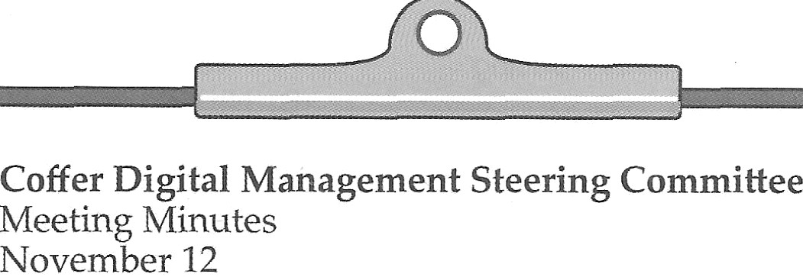

* + 1. Re—pitch is ready to be pilot tested.
    2. The pilot test will be carried out during the first quarter of the fiscal year, January 3—March 31.
    3. Five existing clients will use the experimental version of Re-pitch during the pilot test. They will then take a survey to rate the software's effectiveness, ease of use, and affordability.

If the Re-pitch pilot is successful, a large dollar investment will be needed to design and run an extensive marketing campaign.

5. Our company president will explore potential funding sources for this campaign.



TO:

From:

sales H coffer.com

tcao

Oate: | A3

Sb e tPilot

ewest taipei co t

prils ests

Dear Coffer Digital,

I wanted to follow up after having just submitted our thoughts regarding your Re-pitch marketing software. You will find that our pilot-test feedback is overwhelmingly positive, which is why we would like to be notified immediately upon the rollout of this product. We are very eager to add Re-pitch to our permanent digital marketing efforts.

Sincerely,

Ting Cao, Director of Global Internet Marketing Ewest Clothing Ltd., Taipei

# Business Briefs

Coffer Digital closed a deal yesterday with GPZ Capital. GPZ will make a significant investment in Coffer Digital, enabling the fundings of a new online marketin•g application called Re-pitch. This sales-boosting soft care works by generating a pop-up window that reminds online shoppers of products they have already viewed, after they have navigated away from the product page.

GPZ's knowledge of data and marketing has enabled them to make successful investments in three other software development firms in the past five years. Coffer Digital's strong company reputation and top-notch employees easily support GPZ's decision to invest. “Coffer Digital has a solid plan for distributing• Re-pitch, so it was an easy decision to invest with them,” said Jessica Gould, spokesperson for GPZ.

1. According to the meeting minutes, what is 189.

indicated about the pilot test?

* 1. The testing period will last about three months.
  2. Problems identified during testing must be immediately reported.
  3. Running the test will be costly.
  4. The testing plan still needs the president's approval.

According to the article, what does Re-pitch do?

1. It tracks the sales of online retailers.
2. It prevents pop-up windows in Internet browsers.
3. It offers customers discounts on products.
4. It displays products for online shoppers to consider buying.
5. What did Mr. Cao do?
   1. He redesigned a Web site.
   2. He submitted an annual report.
   3. He completed a survey.
   4. He started a new business.
6. What does Mr. Cao request?
   1. To view the results of a test
   2. To participate in future testing
   3. To be notified when software is available for purchase
   4. To set up a marketing consultation appointment
7. How will Coffer Digital most likely use the funds from GPZ Capital?
   1. To purchase a smaller company
   2. To advertise a product
   3. To hire new employees
   4. To invest in new equipment



Questions 191-195 refer to the following article, e-mail, and sign.



(May 23) Harrison City Airport's Terminal C will reopen to the public on June 1 following a two-year renovation project.

The project added eleven new gates, allowing the terminal to accommodate more flights. The three major airlines that used Terminal C before the renovation will now be back in operation there. Also at Terminal C will be newcomer Paik Airways, a regional carrier that is expanding its routes.

The terminal's new lobby features an efficient check-in process and a state-of- the-art baggage-handling system.

Passengers will enjoy free Wi-Fi in the waiting area, which also contains shops and restaurants.

At one point during the renovations, it looked as if I.he construction team would miss its deadline. An environmental impact review conducted by thc city questioned the placement of a parking lot. The planners solved the pToblem by moving the parking lot to the other side ot the airport and instituting a shuttle bus service.

“Thanks to the cooperative efforts of all stakeholders, the project was completed by the deadline with no budget overage,” said Arturo Benetti, the airport’s chief operating oñicer. “The improvements to Terminal C will enable us to continue providing Harrison City with safe, comfortable air travel.”



From: Tho as rna Yee <th as rna yee coo e b o hers con > To: S en Paulsen <sven p ulsen cooverb o he s com>

Date: July 6 Subject Meeting with Slonim Company buyers

Hello, Sven,

I’m at the Harrison City Airport to catch the 3:30 flig•ht home, but I want to give you a quick update. The meeting at Slonim went well. They are very pleased with Coover Brothers products and expect to double their orders next year. In fact, they offered to feature our bedroom and dining• room sets at the upcoming• Home and Garden Exposition. I'll give you all the details tomorrow.

Regards,

Thomasina



|  |  |  |  |  |  |  |  |
| --- | --- | --- | --- | --- | --- | --- | --- |
|  | | | | | | | |
| HARRISON CITY AIRPORT-TERMINAL C  DEPARTURES | | | | | | | |
| ) | Airline | Flight | Gate | Time | DesG.nation | Status | I |
|  | Brightway | BR417 | 11 | 1:25 | Detroit | ONTIME |  |
|  | PlanetZ | PL700 | 3 | 2:06 | Omaha | CANCELED |  |
|  | Paik | PA069 | 24 | 3:00 | Cleveland | ONTIME |  |
|  | Windrover | WI645 | 6 | 3:30 | Chicago | DELAYED |  |
|  | | | | | | | |
|  | | | | | | | |

1. Why was it necessary to change the location of a parking lot?
   1. To reduce construction costs
   2. To protect the environment
   3. To make travel easier for passengers
   4. To provide spaces for large vehicles
2. What does Mr. Benetti emphasize about Terminal C?
   1. It is the only terminal with free Wi-Fi.
   2. It was designed by a famous architect.
   3. Its renovation was funded by the city.
   4. Its renovation was completed on time.
3. What products does Coover Brothers most likely manufacture?
   1. Furniture
   2. Clothing
   3. Kitchen appliances
   4. Gardening tools
4. What is implied about Brightway Airlines?
   1. It is an international carrier.
   2. It offers flights to Omaha.
   3. It used Terminal C before the renovation.
   4. It has a private waiting area for passengers.
5. What is suggested about Ms. Yee?
   1. She works in Omaha.
   2. She met with Mr. Benetti.
   3. Her flight departed late.
   4. Her luggage was lost.





Questions 196-200 refer to the following brochure, form, and e-mail.



Zell Exteriors' metal roofing products offer many advantages over traditional roofing materials.

Benefit 1—Weather resistance: For questions about specific products or Technology that provides greater protection to request a quote from our sales staff, from hail, wind, and rain complctc our onlinc contact form. All uur

Benefit 2—Wide selection:

Large selection of panel types, trim options, and paint colors to choose from

Benefit 3—Satisfaction guarantee:

30-year warranty for adcled peace of mind

Benefit WEstablished reputation: Quality roofing from a trusted company

roofin.g pane!s are fabricated at one of our regional manufacturing facilities, precut to the necessary dimensions for your roof, and shipped to a branch near you. Our professional installers will then take

it from there.



|  |
| --- |
|  |
| Name: Gus Keenan  E-mail: g enan au oewri e net  Phone: 0555 188s  Comments:  I have been looking at various roofing materials, and the wide range of paint opflons makes yoUF cOM any my top choice. My shed building is an odd shade of purple, and I want to find a color that complements it. But I have a quesflon. I would like the new metal roof to be placed on top of the old shingle roof I have. This would save money on time, labor, and disposal.  Is that something you recommend? I have spent a lot of time reading online forums for professional contractors, and there are mixed opinions about this. |
|  |



|  |  |  |
| --- | --- | --- |
| To: From: | g.keenan H autoewrite.net conmshe t zellexte io s |  |
| Date: | May 2 |
|  | Ro ng Inq iry |
|  | Zel Exteriors ca 1 • |
|  |  |
| Dear Mr. Keenan,  A sales representative will contact you by phone within 45 hours, but first please look over the attached product catalog. Here are the tour basic roofing types that we offer:  SLP Snap Lock — Steel panels with a locking feature that enables i apid instal1ati‹an.  XM Panel — Aluminum panels with superior corrosion resistance. ldeal for wet climates. QR Rigid — Low-cost panels that can be installed directly on top of an existing roof.  WT Panel — Our most durable commercial-grade steel. Available only in white and gi ay.  Thank you,  Nicola Shertz, Administrative Assistant, Zell Exteriors | | |

1. What does the brochure mention about Zell 198.

Exteriors?

* 1. It encourages people to visit a showroom.
  2. It schedules projects several months in advance.
  3. It requires an on-site inspection before installation.
  4. It custom cuts products prior to delivery.

1. Considering Mr. Keenan's comments, what

listed benefit is probably most attractive to 199.

him?

* 1. Benefit 1
  2. Benefit 2
  3. Benefit 3
  4. Benefit 4

What does the form indicate about Mr. Keenan?

1. He has researched about roofing options.
2. He made a mistake when installing some materials.
3. He wants his project completed quickly.
4. He is unhappy with a previous contractor.

What kind of roofing product will Mr. Keenan most likely select?

1. SLP Snap Lock
2. XM Panel
3. QR Rigid
4. WT Panel



200. What does Ms. Shertz tell Mr. Keenan?

1. He can save money by not delaying a decision.
2. He should look over a proposed contract.
3. He will be called by a ZeII representative.
4. He ordered the wrong materials in the past.

Stop! This is the end of the test. If you finish before time is called, you may go back to Parts 5, 6, and 7 and check your work.